BATCH CREATION:

1) Press the Green M
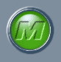
2) Press Batches Menu
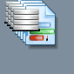
3) Press All Batches
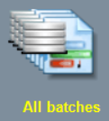
4) Press Active Batches
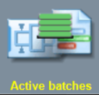
5) Press Batch Creation
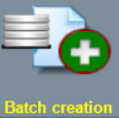
6) Select Part Program for NEW BATCH: ie _100%_B
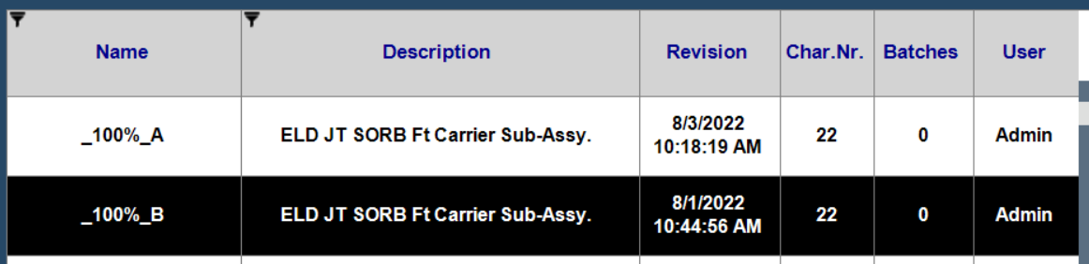
7) Select Batch
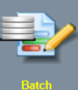
8) Type in NEW name: ie: TEST
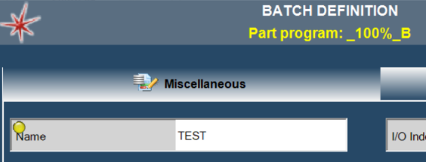

9)Confirm Automatic data export. (if connected to a network or USB stick):
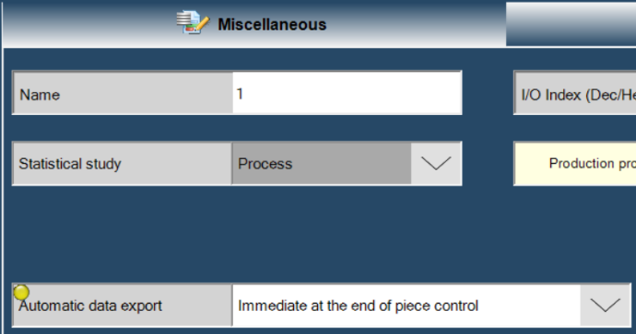
10) Confrim Automatic deletion & Automatic change:
11) Press OK
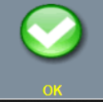
12) Press Measure
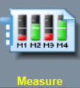
13) Press Start / Stop till ALL steps are complete:
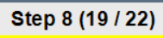
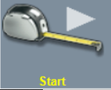
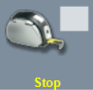
14) If part is GOOD green circle will appear on the top left of the screen.

Press OK and or Delete Part or Step
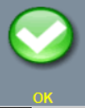
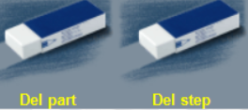

Confirm Location and format of export:

1)Press Green M
2) Press settings
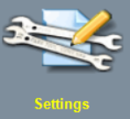
3) Next Page

4) Press Global Setup
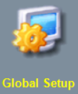
4) Press Data export tab
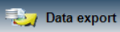
5) Press other Data export tab: confirm data location.
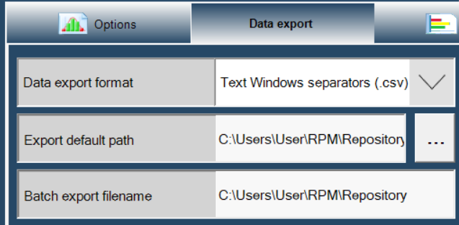
5)Press OK
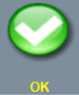
6) When cycle is complete file will be transfer to the Data export area…ie:
C:\Users\User\RPM\Repository

test-Mach 1 Station 1 & 2-0000000002-307100757.csv

